Global Referral User Manual

A step by step navigational process

November 2013

Prepared by: FEi Systems

Contents

1 Access Global Referral 1

2 Create MFP Options Counseling Referral 1

3 Create InterRAI HC MD Request 2

4 Create MDOD Self-Direction Training Referral 2

5 Create Other Referral 3

# Access Global Referral

To create a referral through global referral, you must login as permitted user

1. Log in as the permitted user
2. Search for client under *Clients* tab
3. Click **Client Summary** for client
4. Click “Global Referral” from left navigation, then click “Create Referral”
5. Select desired referral type from “Referral Type” drop-down and click “Go”

1. Click “Global Referral” from left navigation, then click “Create Referral”
2. Select desired referral type from “Referral Type” drop-down and click “Go”


# Create MFP Options Counseling Referral

1. Access **Global Referral**
2. Select **MFP Options Counseling** from **Referral Type** drop-down List
3. Click **Go**

1. Select MFP Options Counseling from Referral Type drop-down List
2. Click Go


1. Complete referral form and click **Submit**

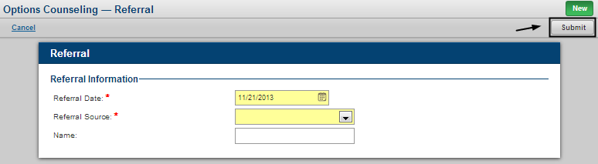

1. A pending MFP Options Counseling referral is created

# Create InterRAI HC MD Request

To create an InterRAI HC MD request, you must log in as the permitted user.

1. Access **Global Referral**
2. Select **InterRAI HC MD Request** from **Referral Type** drop-down List
3. Click **Go**

1. Select InterRAI HC MD Request from Referral Type drop-down List
2. Click Go


1. Complete request form and click **Save & Submit**

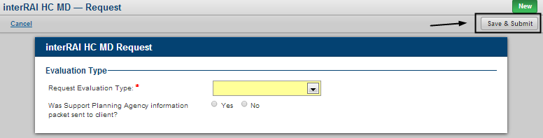

1. An InterRAI HC MD request is created

# Create MDOD Self-Direction Training Referral

To create a MDOD Self-Direction Training Referral, you must log in as the permitted user.

1. Access **Global Referral**
2. Select **MDOD Self-Direction Training** from **Referral Type** drop-down List
3. Click **Go**

Click Global Referral from left navigation and then click “Create Referral”;
Select MDOD Self-Direction Training from Referral Type drop-down List;
Click Go


1. Complete referral form and click “**Save** & **Submit”**

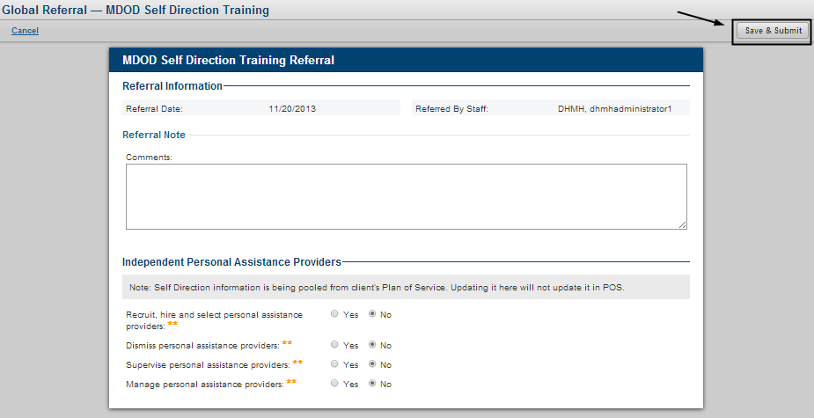

1. A pending MDOD Self-Direction training referral will be created

# Create Other Referral

To create an Other Referral, you must log in as the permitted user.

1. Access **Global Referral**
2. Select **Other** from **Referral Type** drop-down List
3. Click **Go**

1. Select Other from Referral Type drop-down List
2. Click Go


1. Complete referral form and click **Save & Submit**

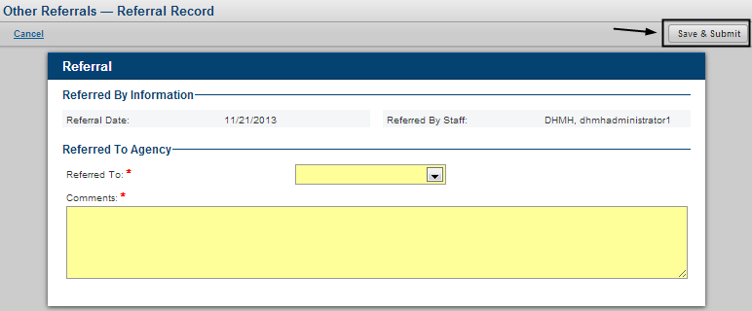

1. An other referral is created and alert is sent to “Referred To” agency
2. To view “Other Referral” history, click “Other Referral History” from left navigation menu

